**Chapter 3: Research Design and Methodology**

This chapter includes the Research Design, a strategy for answering your [research question](https://www.scribbr.com/research-process/research-questions/) using empirical data. The Research Instrument may consist of questionnaires, surveys, interviews, checklists or simple tests. It will also be strongly related to the actual methods that will be used in the specific study. The Procedure section includes the step-by-step processes that the researchers will execute. These processes cover everything from the prototype's conception and design to hardware assembly, device programming, and testing environment setup and design. Data collection is a systematic process of gathering observations or measurements. It allows you to gain first-hand knowledge and original insights into your [research problem](https://www.scribbr.com/research-process/research-problem/). Disposal protocols are included, outlining the researcher's responsible approach to environmentally disposal methods. Risk and Safety is prioritizing safety and conducting thorough risk assessments, researchers can minimize harm to participants and ensure the ethical conduct of their studies.The researcher's careful approach to data and equipment preservation is explained in detail in the storage strategies. An anticipated list of costs and expenses is included in the budget proposal, which will give an idea of how much money will be spent overall to carry out this investigation.

**Research Design**

The study used quantitative research, specifically a developmental and experimental research design. This study falls under the quantitative research category because its primary focus was on gathering and analyzing measurable data. For instance, the researchers collected quantitative data from the smart bin’s components, including the ultrasonic sensor’s distance measurements and the weight sensor’s readings to determine when the trash reaches its height or weight threshold and trigger an alert to MENRO authorities. They also measured the response time of the GSM module in sending notifications, and the accuracy of the GPS module in providing real-time location data. The RFID module was assessed for its effectiveness in unlocking the bin for authorized users, while the ambient light sensor was observed for its ability to activate the solar-powered light when the environment becomes dim or during nighttime. In addition, data was gathered on the locking mechanism’s responsiveness in preventing overflow, and the LCD display’s ability to indicate whether the bin is full or still available for use.

By analyzing the data, the researchers identified patterns and trends that assessed the integrated technology’s performance in real-world settings. The study followed a developmental research approach, which involves the systematic process of designing, testing, and refining technological innovations to ensure effectiveness, usability, and real-world applicability (Plomp & Nieveen, 2018).This approach emphasizes continuous improvement of products through structured testing cycles and evaluations, particularly when addressing practical problems in complex environments.

Developmental research design was one of the subfields of quantitative research design. A thorough investigation into developing, organizing, and assessing educational programs, procedures, and outputs was known as developmental research design. The primary objective was to ensure that they fulfilled requirements for effectiveness and consistency. Improving the program or product under development was the main goal of developmental research (Ahmad, 2016). In order to enhance the standard treatment of garbage and incorporate other characteristics that would provide them with more detailed guidance in complicated and unfamiliar surroundings, the researchers decided to employ this kind of research design.

A preliminary survey will be conducted through an interview with a representative from the Municipal Environment and Natural Resources Office (MENRO) to gather initial insights on the reliability and potential effectiveness of the solar-powered trash can. The interview will follow a set of structured questions and will be validated by selected MENRO faculty members to ensure its accuracy and relevance

The study also employed the survey method to evaluate the acceptability level of the device based on criteria such as reliability, sensitivity and cost-effectiveness. The interview consisted of structured open-ended questions aimed at collecting specific data aligned with the objectives of the study (Singleton & Straits, 2009).

**Respondents of the Study**

The respondent for the preliminary survey on the reliability and potential effectiveness of the solar-powered trash can will be from the Municipal Environment and Natural Resources Office (MENRO).

The respondents for the acceptability survey on the reliability and potential effectiveness of the solar-powered trash can has two groups. We will sample 10 staff members of the Municipal Environment and Natural Resources Office (MENRO) and 20 respondents from local households. The criteria for MENRO staff will be as follows: a.) must be a MENRO staff of Municipality of Lambunao, b.) must be in the service for a minimum of 2 years. For the households respondents, the criteria will be as follows: a.) must be of legal age (18 years or older), b.) must be a legal guardian of the household. We will use purposive sampling for the MENRO personnel and convenience sampling for the local households. According to Nikolopoulou (2023), purposive sampling refers to a group of non-probability sampling techniques in which units are selected because they have characteristics that you need in your sample. In other words, units are selected “on purpose” in purposive sampling. Convenience sampling is a non-probability sampling method where units are selected for inclusion in the sample because they are the easiest for the researcher to access. This can be due to geographical proximity, availability at a given time, or willingness to participate in the research. Sometimes called accidental sampling, convenience sampling is a type of non-random sampling (Nikolopoulou, 2023).

**Research Instrument**

The researchers will utilize two instruments in this study: 1) a survey to determine how effective is the current waste collection and monitoring system in the Municipality of Lambunao, and what innovations can be introduced to improve public trash management, and 2) an acceptability questionnaire to evaluate the device’s performance.

For the first research instrument, the researchers will conduct an interview with the following set of questions:

* What type of waste is usually collected in the Municipality of Lambunao?
* What is the estimated amount of trash, in tons, collected annually in the Municipality of Lambunao from 2023 to 2025?
* How many times in a week do you collect garbage in different barangays?
* Which public places usually have more trash accumulation?
* How often have you seen a trash can overflowing?
* What problem/s occurred while collecting garbage?
* How do you currently track or monitor public trash cans’ usage or condition?
* What do you think should we innovate in our device for future improvement?

For the second research instrument, the researchers will conduct a survey with the following set of questions evaluating the reliability, sensitivity, and cost-effectiveness of the device. A respondent will assess his/her satisfaction using a Likert Scale, ranging from "poorly acceptable" to "highly acceptable." The following questions will be included:

**Reliability.** (the ability of a device to function without failure)

What is the level of acceptability of the device based on the reliability of the:

* ultrasonic sensor in determining the accumulated trash reaches the set height threshold
* weight sensor to detect the pressure exerted by the accumulated trash reaches the set weight threshold(kg)
* automatic overflow prevention locking mechanism’s consistency in engagement
* LCD display’s ability to show the bin’s status in terms of fullness or availability for further use
* assessment of the GSM (Global System for Mobile Communications) module in delivering timely and consistent messages across different network conditions and geographic locations
* accurate location data sent by the GPS (Global Positioning System) sensor
* frequency of the RFID ( Radio Frequency Identification ) sensor can scan the same tag successfully and give the same result every time
* consistency of the ambient light sensor to adjust brightness according to the environment

**Sensitivity.** (the ability of the instrument to detect changes and respond accordingly)

What is the level of acceptability of the device based on the sensitivity of how long the:

1. ultrasonic sensor can quickly detect when the trash reaches the maximum height threshold and trigger the corresponding system responses, with a response time of less than one second.
2. weight sensor can quickly detect when the accumulated trash reaches the maximum weight threshold and trigger the corresponding system responses, with a response time of less than one second
3. locking mechanism can quickly engage once the bin is detected as full, with response time measured in seconds.
4. LCD display updates to show the bin’s status once fullness is detected, emphasizing the response time in seconds (s)
5. GSM (Global System for Mobile Communication) module to send a message to the MENRO across different locations in seconds (s)
6. GPS (Global Positioning System) sensor can detect and maintain satellite signals under various environmental conditions, focusing on its minimum signal strength (measured in dBm) required for accurate and reliable location tracking
7. RFID ( Radio Frequency Identification ) can scan the same tag to unlock the trash bin cover, with response time measured in seconds.
8. ambient light sensor can respond to changes in lighting conditions, focusing on its response time measured in milliseconds

**Cost-Effectiveness.** (the feasibility of purchasing the device at a reasonable cost)

What is the level of acceptability of the device based on its cost-effectiveness in accordance to its:

* reliability
* sensitivity

The data collected from both instruments will be analyzed using statistical tools such as binomial test, mean, and standard deviation in Jamovi Statistical Software (version 2.5.6).  All the instruments that will be used will be validated by ICT experts and qualified faculty of the school. These will also undergo pilot testing and will be assessed using Cronbach Alpha to ensure reliability.

**Procedure**

**Figure 2**

*Procedural Flowchart* 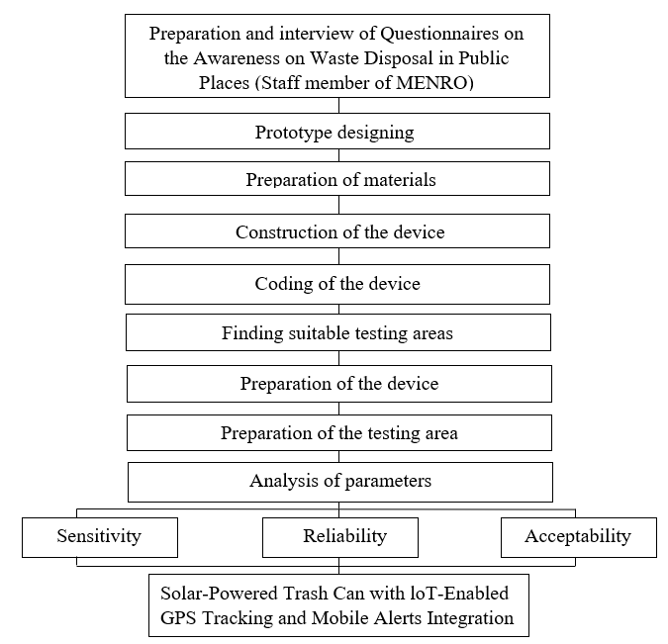

*Note:* The main steps of conducting the device includes the survey on the level of awareness of an individual part of the MENRO staff on waste disposal, prototype designing, preparation of materials, constructing of device, coding of the device, finding suitable testing areas, preparation of device, preparation of the testing area, and analysis of parameters.

**Prototype Design**

**Figure 3.**

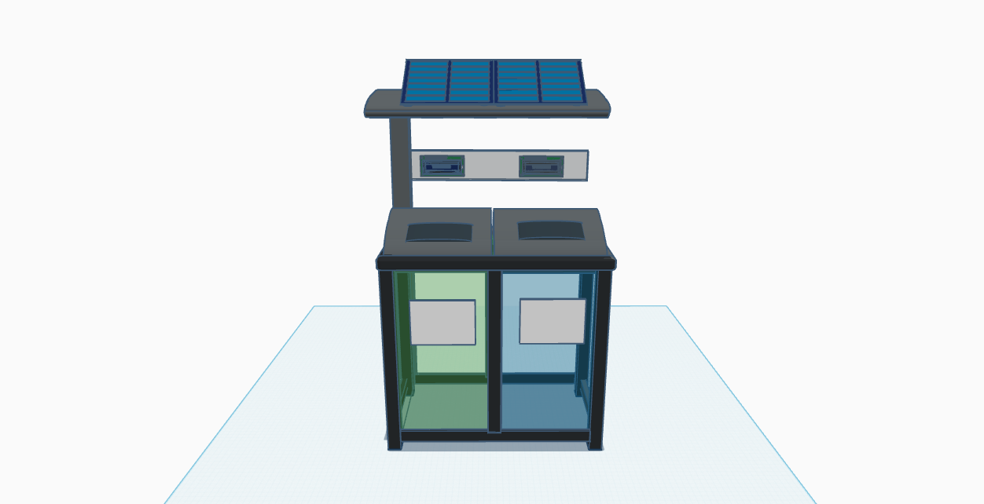

**Circuit Diagram**

**Coding**

**Coding Flowchart**

**Data Collection and Analysis of Parameters**

1. To determine the amount and type of waste, as well as the frequency of trash collection recorded by MENRO (Municipal Environment and Natural Resources Office) within the municipality of Lambunao, Iloilo.

To determine the amount and type of waste, as well as the frequency of trash collection recorded by MENRO in Lambunao, Iloilo, we will conduct an interview using a set of structured questions. The interview responses will be validated by three personnel, consisting of faculty members from Lambunao National High School and MENRO officers.

2. To determine the reliability of the smart bin device in terms of:

1. accurate detection of the ultrasonic sensor in determining when the accumulated trash reaches the set height threshold

The ultrasonic sensor will be evaluated for its consistent performance in detecting and reporting when the accumulated trash in either of the two compartments reaches the 20-inch height threshold. The bin measures 24 inches tall and 20 inches wide, and once the threshold is reached, the sensor will activate the other system components indicating full capacity.

1. ability of the weight sensor to detect when the pressure exerted by the accumulated trash reaches the set weight threshold

The weight sensor will be evaluated for its reliability in accurately detecting and reporting when the accumulated trash in either of the two compartments reaches the maximum weight threshold of 7.5 kg, signifying that the compartment is full and triggering the activation of the other system components.

1. testing the automatic overflow prevention locking mechanism’s consistency

The automatic overflow prevention locking mechanism will be tested for its consistent engagement every time the bin indicates full status, effectively preventing spillage. This mechanism is triggered when either the ultrasonic sensor or the weight sensor detects that the trash has reached its respective threshold, signifying full capacity, at which point the cover of the trash can will be securely locked.

1. evaluating the LCD display’s ability to show the bin’s status in terms of fullness

The LCD screen will be evaluated for its functionality in clearly displaying the bin’s status if it is full or still available for use, which will be triggered whenever either the ultrasonic sensor or the weight sensor detects that the bin has reached its full capacity.

1. assessment of the GSM (Global System for Mobile Communications) module in delivering timely and consistent messages across different network conditions and geographic locations

Once either the ultrasonic sensor or the weight sensor detects that the bin has reached full capacity, the GSM module will be triggered to automatically send a notification message, along with the GPS location, to the assigned MENRO authorities. The GSM automated notification system's consistency will be evaluated by verifying that alerts are reliably sent through a text message with a prompt shown below.

*“Greetings, authorities.*

*This is an automated alert from the waste monitoring device. The SIGMA is now full.*

*Type of waste: Non-biodegradable/ Biodegradable.*

*Location: [Insert exact location].*

*Kindly take appropriate action at your earliest convenience.*

*Thank you and have a safe day.”*

This message is sent to MENRO each time any of the trash bin compartments reaches full capacity.

1. accuracy of the location data sent by the GPS (Global Positioning System) sensor

The GPS module will be evaluated for its ability to provide precise geographical coordinates of the full trash can, with the location data integrated into the GSM notification message that is sent to the assigned MENRO authorities

1. frequency of the RFID ( Radio Frequency Identification ) sensor in scanning the same tag to unlock the trash bin cover

The RFID system’s consistency in authentication will be assessed by evaluating its ability to successfully recognize and scan the authorized MENRO tag to unlock the trash bin cover once it has been locked due to full capacity, ensuring that the bin can be accessed and made available for use again.

1. consistency of the ambient light sensor to adjust brightness of the LED lamp according to the environment

The ambient light sensor’s consistency will be evaluated by assessing its ability to automatically and consistently adjust the LED lamp based on the detected brightness of the environment, increasing brightness in dim conditions and reducing it in brighter settings.

Each of these components will be tested 10 times in field trials. The interpretation of the reliability of the device will be based on a table shown in the next page.

**Table 1**

*Interpretation on the Reliability of the Device*

| Range of Success Rate (in %) | Descriptive Indicator |
| --- | --- |
| Below 80 | Poorly Reliable |
| 80-85 | Fairly Reliable |
| 86-90 | Moderately Reliable |
| 91-95 | Reliable |
| 96-100 | Highly Reliable |

Note. This table shows the interpretation on ranges of descriptive indicators where: ranges below 80% indicate as poorly reliable, 80-85 as reliable, 86-90 as reliable , 91-95 as moderately reliable, and 96-100 as highly reliable.

**Sensitivity.**

1. To determine the sensitivity of the smart bin device in terms of how long the:

1. ultrasonic sensor can quickly detect when the trash reaches the set height threshold, with a response time of less than one second.
2. weight sensor can quickly detect when the accumulated trash reaches the maximum weight threshold, with a response time of less than one second
3. locking mechanism can quickly engage once the bin is detected as full, with response time measured in seconds.
4. LCD display updates to show the bin’s status once fullness is detected, emphasizing the response time in seconds (s)
5. GSM (Global System for Mobile Communication) module to send a message to the MENRO across different locations in seconds (s)
6. GPS (Global Positioning System) sensor can detect and maintain satellite signals under various environmental conditions, focusing on its minimum signal strength (measured in dBm) required for accurate and reliable location tracking
7. RFID system can recognize and scan tags under different conditions, focusing on the time in seconds and its ability to work without direct contact
8. ambient light sensor can respond to changes in lighting conditions, focusing on its response time measured in milliseconds

To assess the sensitivity of the smart bin, the analysis will be based on the parameters outlined in the reliability objectives, but will specifically focus on how quickly each sensor and system component responds to its designated condition or trigger within a given period of time.We, the researchers will conduct 10 trials, simulating various operational scenarios to evaluate the sensitivity of the smart bin's components. The collected time responses will then be analyzed using descriptive statistics (mean and standard deviation) in Jamovi Statistical Software, with interpretations based on the table shown below.

**Table 2**

*Interpretation on the Sensitivity of the Device*

| Ranges of Average Time Responses  (in seconds) | Descriptive Indicator |
| --- | --- |
| Greater than 2.49 | Poorly Sensitive |
| 2.00 - 2.49 | Fairly Sensitive |
| 1.50 – 1.99 | Moderately Sensitive |
| 1.00 – 1.49 | Sensitive |
| Less than 1 | Highly Sensitive |

Note. This table showed the researcher- made interpretation on the responsiveness of the device where: greater than 2.49 as poorly sensitive, 2.00 – 2.49 as fairly sensitive, 1.50 – 1.99 as moderately sensitive, 1.00 – 1.49 as sensitive, and less than 1 as highly sensitive.

**Acceptability.**

Determine the acceptability of the device in the community using a Likert's scale survey in terms of its reliability, sensitivity, and cost effectiveness. This will be interpreted using the descriptive indicators shown on Table 3.

To assess the acceptability of the device within the community specifically by 10 MENRO personnel and 20 households, we will employ a Likert scale survey focusing on the device’s reliability, sensitivity, and cost-effectiveness. The interview will be administered to one authorized MENRO staff member, who will serve as the key respondent in evaluating the device’s acceptability. The interpretation of the acceptability of the device will be based on the table below.

**Table 3**

*Interpretation of the Acceptability of the Device*

| Level of  Acceptability | Descriptive Indicator |
| --- | --- |
| 1.00 – 1.49 | Poorly Acceptable |
| 1.50 - 2.49 | Fairly Acceptable |
| 2.50 – 3.49 | Moderately Acceptable |
| 3.50 – 4.49 | Acceptable |
| 4.50 – 5.00 | Highly Acceptable |

Note. This table showed the interpretation on ranges of descriptive indicator where: ranges 1.00 – 1.49 indicates as poorly acceptable, 1.50 – 2.49 as fairly acceptable, 2.50 – 3.49 as moderately acceptable, 3.50 – 4.49 as acceptable, and 4.50 – 5.00 as highly acceptable (Terano, 2015).

### **Statistical Data Analysis Procedure**

The statistical software that the researchers will use in this study includes Jamovi Statistical Software (version 2.5.6) for data organization and descriptive analysis. Statistical tools include descriptive statistics (binomial test, mean, and standard deviation) and Cronbach’s Alpha to test the reliability of survey instruments.

**Binomial Test.** A binomial test is a statistical test used when dealing with a single dichotomous (two-outcome) variable (S. Lewis-Beck et al., n.d.).This will be also used in determining the results from the data in testing the reliability of the device under various environmental conditions, as well as in evaluating the reliability of the sensors in detecting accurate values and responses under time constraints.

**Mean and Standard Deviation.** The mean or average, is a measure that represents the central value of all numbers in a dataset (Eads, 2025) will be used to measure the average sensitivity and accuracy of the different sensors, as well as the overall cost-effectiveness based on user feedback. The standard deviation is a statistical measure that shows how spread out the data points are relative to the mean (Omda & Sergent, 2024) will assess the variation in sensor outputs, response times, and user ratings, indicating the consistency of the device’s performance.

**Ethical Considerations**

The respondent from the (MENRO) Municipal Environment and Natural Resources Office who will participate in this study will be provided information regarding the study's objectives, procedures, and potential benefits. The resident will be given an idea what is the purpose of the study and how the data would be used. Confidentiality will be strictly upheld including the details in the report and securely storing all collected data to hide their identity. The interview will be informed consent to ensure voluntary participation, with the respondent made fully aware that they had the right to withdraw at any time without facing any consequences. The interview will be conducted with respect to the respondent’s time, and all the efforts will be made to ensure that the questions were appropriate, and relevant to the research. By observing these ethical standards, the study maintains integrity and ensures that the respondent’s rights and dignity will be protected throughout the research.

### **Risk and Safety**

The improper handling of organic waste can lead to the proliferation of vermin and disease-carrying insects, which further exacerbates health risks in communities (*Guidance on Solid Waste and Health*, n.d.). Furthermore, littering adversely affects the environment. Littering along the road, on the streets or by the litter bins, toxic materials or chemicals in litter can pollute soil environments. Litter also reduces air quality due to the smell and toxic/chemical vapor emanating from the trash. A polluted environment can encourage the spread of diseases (Environment cenn, 2018). The researchers were careful when it comes to batteries because heavy metals , including lithium, nickel cadmium or lead-acid, are a definite no-no when it comes to your trash. These include car batteries, camera batteries, cell phone batteries and similar batteries, basically any rechargeable battery. The danger from batteries is very real; batteries alone cause fires in garbage trucks and disposal facilities (Help Prevent Trash, n.d.) Electricity is a hazard, as it has the potential to cause harm, but if properly managed, the likelihood of harm being caused is minimal. Although, the severity of electrical hazards (sometimes referred to as consequence) when things go wrong will potentially be fatal or life changing Electrical hazards may cause personal injury from electric shock and electric burn (Smith, 2023) Waste collection personnel, the hazards of collecting and managing overflowing refuse entail infections, long-term illnesses, and accidents. Direct exposure to waste can lead to skin and blood infections via infected wounds, several diseases caused by animals that feed on the waste, and intestinal infections spread by flies that feed on the waste. Collecting overflowing trash is also dangerous because of sharp items, needles, and possibly hazardous materials (Ecube Labs Co., Ltd., 2021) Risks in fires during device construction arise from sources of ignition like hot work and temporary heaters, flammable materials and gases, faulty electrical systems and equipment, and the potential for arson. These risks can lead to severe damage, injuries, and project delays (Evans, 2024).

To lower this risk, we always wear proper personal protective equipment, such as gloves and masks, when handling garbage, garbage bins must be regularly cleaned and disinfected to prevent the spread of diseases, sharp or hazardous waste should be disposed of separately in designated containers to avoid injuries, we must be trained on safe lifting techniques and proper handling of waste materials, garbage collection schedules should be strictly followed to prevent overflow and reduce health, people should avoid scavenging in garbage dumps to minimize exposure to harmful substances (Sensoneo, 2025). We can also wear protective gloves and safety glasses when handling old electronics or batteries to avoid cuts and exposure to harmful chemicals (*Safely Handling Electronic Waste*, 2020) To prevent fires during device construction, we controlled ignition sources, manage combustible materials, implement safe electrical practices, and ensure fire safety equipment is available (*Fire Prevention*, n.d.)

**Storage and Disposal**

The solar panel, GPS module, microcontroller (such as the Arduino Uno), sensors (ultrasonic, infrared, and weight sensors), and power supply will be all meticulously cleaned to get rid of any dust or dirt before being stored. To prevent electrical dangers, the researchers will make sure that every component will be unplugged from power sources and thoroughly cleaned every part with a soft cloth or brush. To guard against deterioration from heat, moisture, or sunlight, the materials will be kept in a dry, well-ventilated space. In order to preserve the devices' functioning and integrity, extreme environmental conditions will be avoided. Soft materials like foam or bubble wrap will be used to cushion the components in order to shield delicate electronics from physical assaults. Defective or unusable items, particularly electronic garbage, will be disposed of by segregation and in compliance with municipal waste disposal laws. To protect the environment, dangerous parts like batteries will be disposed of in e-waste containers with clear labels.

**Timeline of Activities**

To achieve this research work’s objectives, the researchers have followed the schedule presented in Table 6 below.

**Table 6.**

*Timeline of Activities*

| Activity | Timeline | Duration |
| --- | --- | --- |
| 1) Chapter 1 Draft | June 27 – July 3, 2025 | 7 days |
| 2) Input Questionnaire | July 4-7, 2025 | 4 days |
| 3) Consultation with Sir Surely Win Dilag | July 10, 2025 | 1 day |
| 4) Chapter 3 Draft | July 8-14, 2025 | 7 days |
| 5) Chapter 1 Final | July 15-21, 2025 | 7 days |
| 6) Chapter 3 Final | July 22-28, 2025 | 7 days |
| 7) Slide Deck/PPT | July 29 – August 4, 2025 | 7 days |
| 8) Consultation with Sir Surely Win Dilag  9) Mock Defense | August 13, 2025  September 1, 2025 | 1 day  1 day |
| 10) Proposal Defense | September 3, 2025 | 1 day |
|  |  |  |
| Total |  |  |

**Table 7.**

*Budget Proposal*

| Items/materials | Price per unit (in Php) | Quantity (per unit) | Amount (in Php) |
| --- | --- | --- | --- |
| Ultrasonic Sensor (HC-SR04) | 220.00 | 4 | 880.00 |
| Ambient Light Sensor (BH1750) | 26.00 | 1 | 26.00 |
| RFID Reader Module (RC522) | 152.00 | 2 | 340.00 |
| Liquid Crystal Display(16x2) with I2C adapter | 330.00 | 2 | 660.00 |
| Solar Panel (5V) | 343.00 | 1 | 343.00 |
| Light Emitting Diode strip  Arduino Uno  Li-Ion Battery Pack (3.7V, 2000-3000mAh)  TP4056 Charging Module (with protection)  LM7805 Voltage Regulator  Load Cell with HX711 amplifier (5kg)  Resistors  Servo Motors (SG90)  GSM Module (SIM800L)  GPS Module (NEO-6M)  Breadboard  Jumper Wires | 239.00  505.00  204.00  38.00  22.00  165.00  183.00  99.00  369.00  148.00  59.00  103.00 | 2  1  1  1  1  1  1  2  1  1  1  1 | 478.00  505.00  204.00  38.00  22.00  165.00  183.00  198.00  369.00  148.00  59.00  103.00 |
|  |  |  |  |
| Total |  |  | 4, 886.00 |

*Note:* The budget proposal for this study shows the list of items / materials and services used when conducting the study. The total cost for conducting this study is ₱4,886.00

**References**

Eads, A. (2025, March 25). *What Is the Mean? How To Calculate It (With Examples)*. Indeed. https://www.indeed.com/career-advice/career-development/how-to-calculate-the-mean?

Ecube Labs Co., Ltd. (2021b, February 3). *Overflowing garbage bins: 5 impacts on health and environment, and how to prevent*. Ecube Labs. https://www.ecubelabs.com/overflowing-garbage-bins-5-impacts-on-health-and-environment-and-how-to-prevent

Environment cenn. (2018, March 28). *Reasons, consequences and possible solutions of littering - Caucasus Environmental Knowledge Portal*. Caucasus Environmental Knowledge Portal. https://environment.cenn.org/waste-management/publications/reasons-consequences-possible-solutions-littering

Evans, A. (2024, July 10). *The basics of construction fire safety*. Vanguard. https://vanguard-fire.com/the-basics-of-construction-fire-safety

*Fire prevention*. (n.d.). Health and Safety Authority. https://www.hsa.ie/eng/topics/fire/fire_prevention

*Guidance on solid waste and health*. (n.d.). https://www.who.int/tools/compendium-on-health-and-environment/solid-waste

*Help Prevent Trash Fires: Keep These 5 Materials out of Your Garbage - Granger*. (n.d.). Granger. https://www.grangerwasteservices.com/help-prevent-trash-fires-keep-5-materials-trash

Omda, S. E., & Sergent, S. R. (2024, November 25). *Standard deviation*. StatPearls - NCBI Bookshelf. https://www.ncbi.nlm.nih.gov/books

*Safely handling electronic waste*. (2020, June 23). Safe at Work California. https://www.safeatworkca.com/safety-articles/safely-handling-electronic-waste

Sensoneo. (2025, June 11). *Smart Waste Management Solutions for Cities | SENSONEO*. https://sensoneo.com/smart-waste-management-solution-for-cities

Smith, A. (2023, May 24). *What are electrical hazards? | Dangers of electricity*. Electrical Safety UK. https://elecsafety.co.uk/what-are-electrical-hazards

Statistics Canada. (2021, September 2). *4.3 Frequency distribution*. https://www150.statcan.gc.ca/n1/edu/power-pouvoir/ch8